WHISPERING OAKS RANCH
17410 Bowman Road
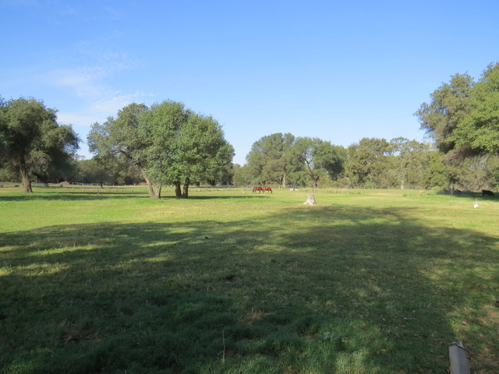
Cottonwood, CA 96022

LOCATION
Whispering Oaks Ranch is located in the Bowman Road area of Cottonwood, in Tehama County, California. The town of Cottonwood, in neighboring Shasta County, has a population of just over 3,000 and is approximately 7 miles from the ranch. The area has long been known for its rustic country flavor, cattle ranches, and annual rodeo, among other attractions. The local livestock sales yard is reputed to do more business in a year, including on-site and online sales, than any other livestock auction yard west of the Rockies.
Cottonwood has excellent schools, grocery and other shopping, and various professional services readily available. Redding, a city with a population of 85,000 and a metropolitan population of more than 177,000, is 15 miles north of Cottonwood. Red Bluff, a city with a population of 14,000, is about 15 miles to the south. Interstate 5 passes through all three municipalities and both Redding and Red Bluff straddle the Sacramento River, home to salmon, steelhead, and rainbow trout. Cottonwood Creek, draining the largest undammed watershed in California, is the dividing line between Tehama and Shasta counties and empties into the Sacramento River just a mile or two east of town.

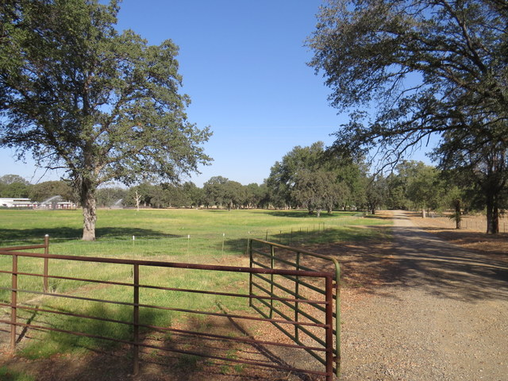
SITE
Whispering Oaks has been the home of the JBL Quarter Horse operation, from which the owners are retiring after more than 30 years. Jim and Susie Leaverton have bred and trained their own cutting and reining horses and have also trained horses for clients. The parklike ranch slopes gently from the paved county road, has a large portion dedicated to irrigated pastures, is home to many very large Valley Oak and other trees, is both perimeter fenced and cross-fenced for horses and cattle, and has two well-defined entrances off of Bowman Road. Among other existing and future uses, the ranch could be used as a horse training facility, livestock breeding center, family ranch, corporate retreat, or special event center.

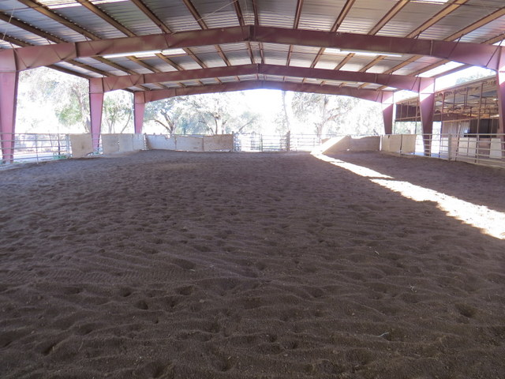
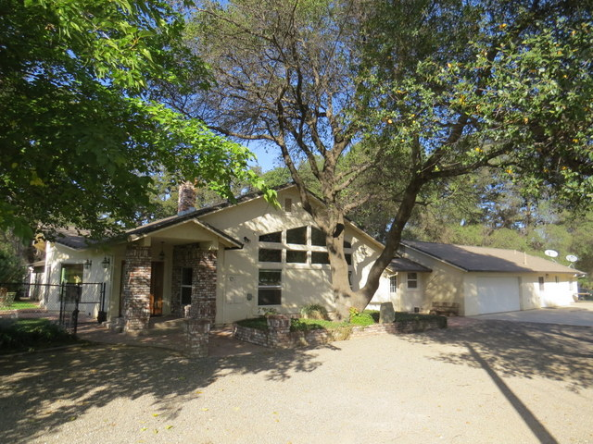
The ranch is made up of 3 legal parcels:
1) Parcel 006-380-049 is 6.28 acres in size and has a 3-bedroom-and-den, 2.5 bath home with pool, an attached 2-car garage, and an attached studio apartment. All together there is approximately 3,170 square feet of living space, according to a recent property appraisal. The home features an open vaulted family room, large dining area adjacent to a large kitchen with central island, a formal living room with a fireplace, a deck off of the dining area, and an extensive patio area surrounding the pool, among other amenities. Also on this parcel are an approximately 140 ft. x 95 ft. two-story metal barn with 8 stalls, including an approximately 100 ft. x 60 ft. arena under cover, and tack room, hay storage, and workshop areas. There are also a variety of round pens, corrals, loafing sheds, and an outdoor riding arena.

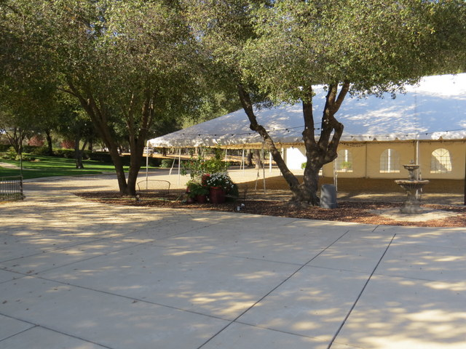
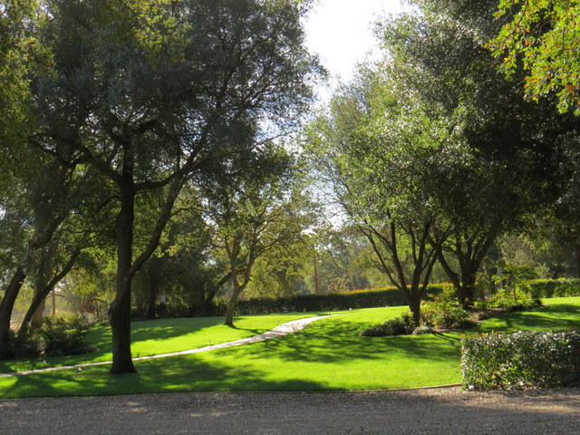
2) Parcel 006-380-019, the largest parcel, is a parcel of 19.32 acres. This parcel has its own entrance off of Bowman Rd. and it is designed and used as a special events venue for weddings, receptions, fund raisers, and other similar occasions. In addition to the landscaped gardens and parking areas there is a fairly new 2-story metal barn of approximately 85 x 40 feet used for equipment storage, changing rooms, and a kitchen-type staging area for catered meals for the various special events. There is also a one-bedroom apartment on the second floor with an exterior staircase. Also on this parcel, next to the metal barn, is a large special events tent of approximately 60 x 30 feet with an adjacent concrete patio for bands and dancing.

3) Parcel 006-380-050 is a parcel of 13.03 acres that is perimeter and cross-fenced and is used as pasture for horses and cattle.
ZONING
The zoning for all 38.63 acres is R1-A-MH-B:86. This is a rural residential zoning that allows animals and also allows either stick-built or mobile homes on parcels of 2 acres minimum in size. The owners have a use permit to operate the special events center and hold weddings and other events on-site.

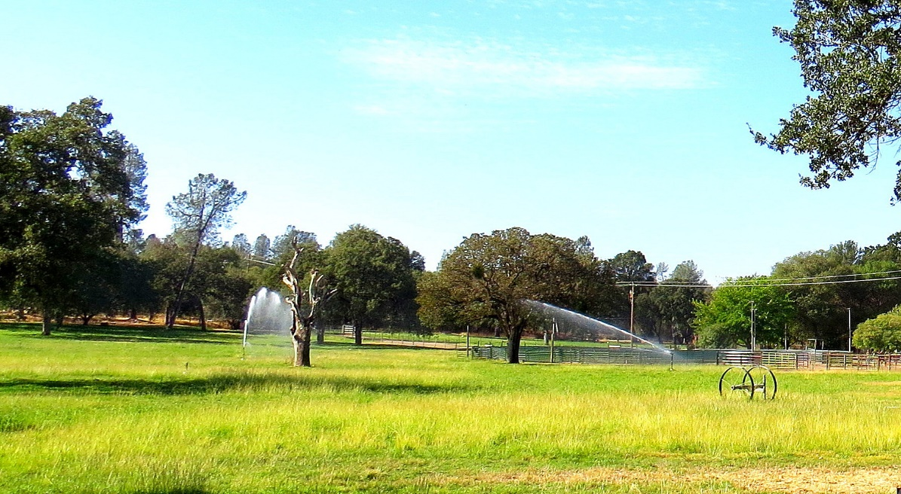

WATER
Parcel 050 has 2 agricultural wells, Parcel 049 has a domestic well and Parcel 019 has an agricultural well. Productivity of each well is unknown until tested, but the owners currently have irrigation set up for approximately 75% of the pastures on the property and are never short of water. The central Cottonwood area in general, and the Bowman Road area in particular are known to have plentiful water both historically and currently. Farms in the immediate vicinity grow alfalfa and French plums (prunes), along with wheat and wheat hay, oats and oat hay, and grass and various mixed-grass hays. Cattle grazing is also a major use of Cottonwood area lands.

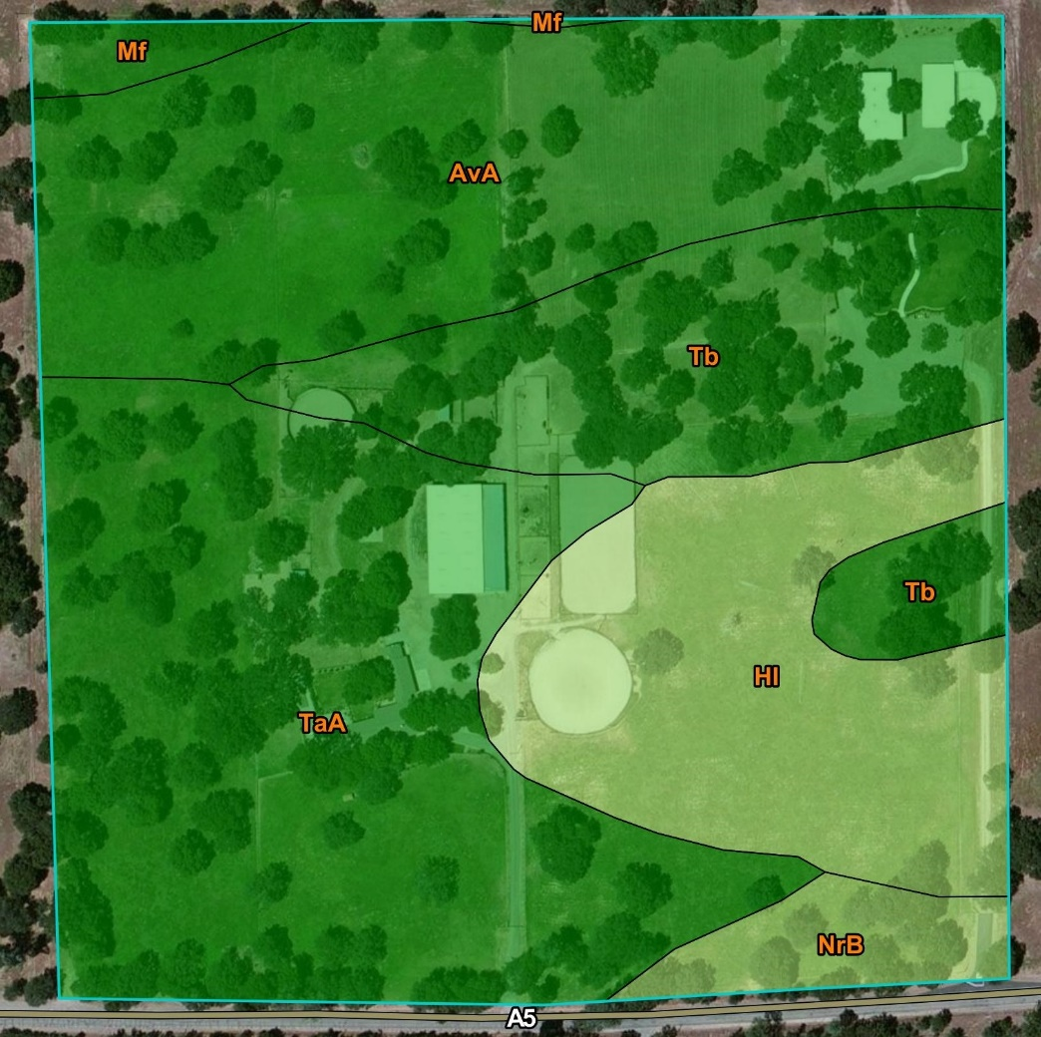
SOILS
Natural Resources Conservation Service soil maps indicate a Storie Index of the following soil types and approximate percentages:
33% Tehama loam (Grade 1-Excellent)
28% Arbuckle gravelly loam (Grade 1-Excellent)
17% Hillgate silt loam (Grade 3-Fair)
17% Tehama gravelly loam (Grade 1-Excellent)
3% Newville gravelly loam (Grade 2-Good)
2% Maywood loam (Grade 1-Excellent)

Though the current owners have focused on livestock, given the mostly excellent soils, gently sloping land, and plentiful water, it appears that the ranch may have good potential for a variety of orchard, garden, and row crops. If interested, please consult with Tehama County Cooperative Extension or your own farm advisor to get more information and advice.

TAXES
Property taxes in Tehama County for properties not contracted as Agricultural Preserve under the Williamson Act are nominally 1% of the purchase price. Under Proposition 13 laws, property tax payments in California, if raised, cannot increase by more than 2% per year. This is not a Williamson Act property.

SALE PRICE AND TERMS
The asking price for all three parcels and all improvements, including currently installed portable corral and fence panels and irrigation equipment, is $1,315,000. Some equipment and furnishings may be available and negotiated separately, outside of escrow.

